**Software Requirements**

**Specification**

**For**

**PAKFUEL**

**Version 1.0 approved**

**Prepared by**

**Kaleemullah-54547**

**Waleed Ahmed-52916**

**Muzamil Khan-53643**

**Balochistan University of Information Technology, Engineering & Management Sciences**

**18 November 2023**

Table of Contents

Table of Contents ii

Revision History iv

List of Figures v

List of Tables vi

Chapter 1: Introduction 1

1.1 Purpose 1

1.2 Document Conventions 1

1.3 Intended Audience and Reading Suggestions 1

1.4 Product Scope 1

1.5 References 2

Chapter 2: Overall Description 3

2.1 Product Perspective 3

2.2 Product Functions 3

2.3 User Classes and Characteristics 4

2.4 Operating Environment 4

2.5 Design and Implementation Constraints 5

2.6 User Documentation 5

2.7 Assumptions and Dependencies 6

Chapter 3: External Interface Requirements 7

3.1 User Interfaces 7

3.2 Hardware Interfaces 7

3.3 Software Interfaces 7

3.4 Communications Interfaces 8

Chapter 4: PakFuel Features 9

4.1 Transaction Processing 9

4.1.1 Description and Priority 9

4.1.2 Stimulus/Response Sequences 9

4.1.3 Functional Requirements 9

4.2 Loyalty Program Management 9

4.2.1 Description and Priority. 9

4.2.2 Stimulus/Response Sequences 9

4.2.3 Functional Requirements 10

Chapter 5: Other Nonfunctional Requirements 11

5.1 Performance Requirements 11

5.2 Safety Requirements 11

5.3 Security Requirements 11

5.4 Software Quality Attributes 11

5.5 Business Rules 11

Chapter 6: Logical Designs of System 12

*6.1* Use Case 12

6.1.1 Use Case Diagram – General User 12

6.1.2 Use Case Diagram –Pump Station Owner. 13

6.1.3 Use Case Diagram – Service Personnel 13

6.1.4 Use Case Diagram – Admin. 14

6.2 Descriptive Use Cases 14

6.3 Activity Diagram of System 25

6.4 Data Flow Diagrams 27

6.4.1 Context Level Diagram 27

6.4.2 Level 1 DFDs 27

6.5 Sequence Diagram 28

6.5.1 Sequence Diagram – Digitally Fuel Transaction 28

6.5.2 Sequence Diagram –Loyalty Program System. 29

6.6 Entity Relationship Diagram 31

|  |  |  |  |
| --- | --- | --- | --- |
| **Name** | **Date** | **Reason For Changes** | **Version** |
|  |  |  |  |
|  |  |  |  |
|  |  |  |  |
|  |  |  |  |

Revision History

List of Figures

Figure 1 – General Overview of the App 2

Figure 2 Use Case - General User 12

Figure 3 Use case -Pump Station owner 13

Figure 4 Use Case - Service Personnel 13

Figure 5 Use Case - Admin 14

Figure 6 Activity Diagram -1 25

Figure 7 Activity Diagram -2 26

Figure 8 - Level 0 DFD 27

Figure 9 - Level 1 DFD 27

Figure 10- Fuel Transaction - Sequence Diagram 28

Figure 11- Loyalty Program-Sequence Diagram 29

Figure 12 – Sample Entity-Relationship Diagram 31

List of Tables

Table 1 –Descriptive Use Case Table 14

Table 2 - Descriptive Use Case Table 15

Table 3 - Descriptive Use Case Table 15

Table 4 - Descriptive Use Case Table 16

Table 5 - Descriptive Use Case Table 16

Table 6 - Descriptive Use Case Table 17

Table 7 - Descriptive Use Case Table 17

Table 8 - Descriptive Use Case Table 18

Table 9 - Descriptive Use Case Table 18

Table 10 - Descriptive Use Case Table 19

Table 11 - Descriptive Use Case Table 19

Table 12 - Descriptive Use Case Table 20

Table 13 - Descriptive Use Case Table 20

Table 14 - Descriptive Use Case Table 21

Table 15 - Descriptive Use Case Table 21

Table 16 – Sample Descriptive Use Case Table 24

# Introduction

## Purpose

This Software Requirements Specification (SRS) outlines the requirements for the development of **"PakFuel,"** a digitalized payment and service system for vehicle fueling. The purpose of this document is to provide a comprehensive understanding of the software requirements, guiding the development team and stakeholders throughout the project lifecycle. This SRS covers the entire scope of the **PakFuel** system, detailing both hardware and software components, with a focus on enhancing the user experience and optimizing operational efficiency.

## Document Conventions

* This document has font style Times New Roman with size between from 12 to 14
* The headings in this document are bold with font size 14.

## Intended Audience and Reading Suggestions

The document targets a diverse audience, including developers, project managers, marketing staff, users, testers, and documentation writers. For an optimal understanding, readers are advised to begin with the overview sections and proceed to role-specific segments. The document follows a logical flow, providing comprehensive coverage from the project's purpose to detailed technical specifications.

## Product Scope

**PakFuel,** is an exaggeration system designed to simplify the purchase of fuel, customer retention, and enhance user convenience. The primary objective is to provide users with a seamless digital payment experience while enabling Pump Station Owners to build customer loyalty and increase sales. The system encompasses both hardware and software components, offering a comprehensive solution that addresses challenges related to fueling, and can locate the nearest fuel pump using this app, and in future we can add the service like, vehicle maintenance.

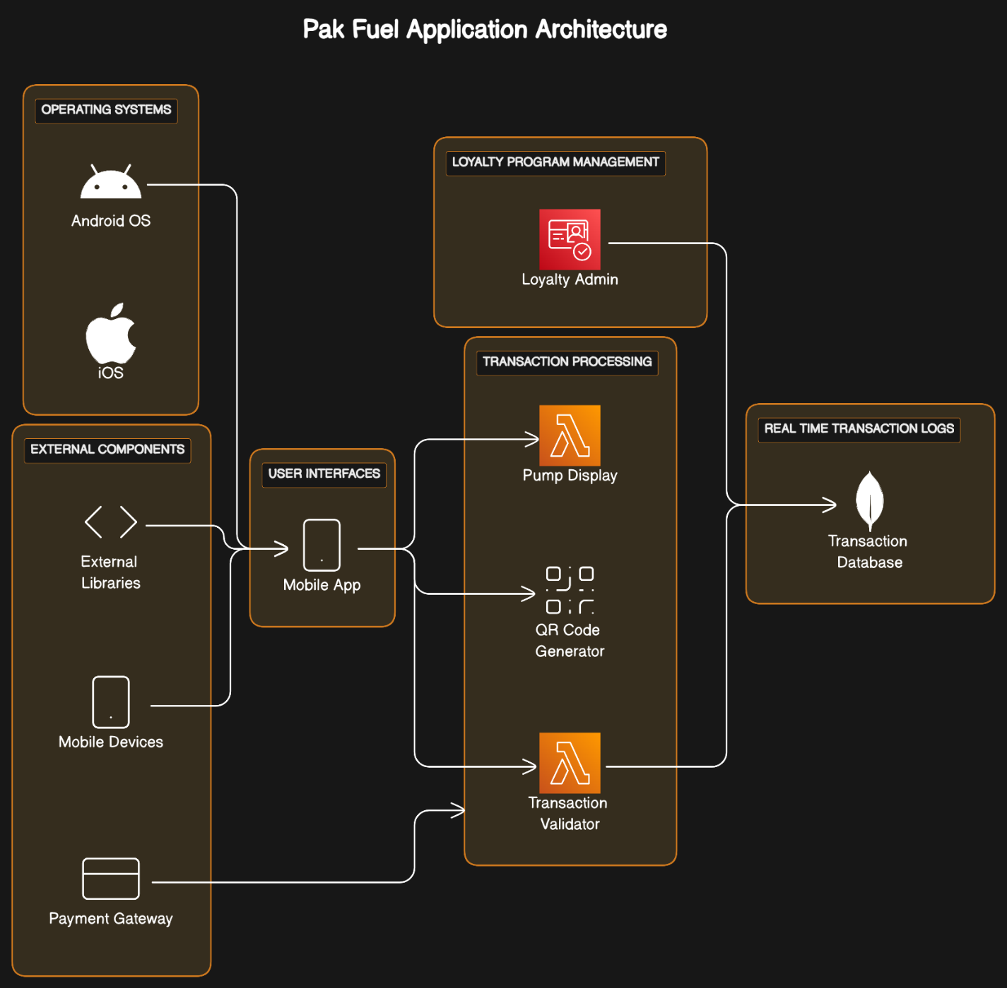

Figure 1 – General Overview of the App

## References

*<List any other documents or Web addresses to which this SRS refers. These may include user interface style guides, contracts, standards, system requirements specifications, use case documents, or a vision and scope document. Provide enough information so that the reader could access a copy of each reference, including title, author, version number, date, and source or location.>*

# Overall Description

## Product Perspective

**“PAKFUEL"** stands at the forefront of innovation in the fuel industry, introducing an advanced mobile application poised to redefine the fuel purchasing landscape. Operating independently, the app boasts a robust mobile architecture, ensuring swift and secure transactions for users. Simultaneously, it seamlessly integrates with existing Pump Station operations, enhancing transaction processing and loyalty program management for station owners. Designed with a strong focus on user-centricity, **"PakFuel"** offers a simplified, user-friendly mobile platform for digital fuel purchases. Pump Station Owners benefit from an intuitive interface, empowering them with effective business oversight. Positioned as a market leader, **"PakFuel"** distinguishes itself through unique features such as a customer loyalty program and real-time transaction logs, marking a departure from traditional Pump Station systems. In crux, **"PakFuel"** is not just an app; it's a transformative solution that combines autonomy and integration, reshaping the landscape of digital fuel transactions.

## Product Functions

In this section, we present a brief overview of the core functionalities that **"PakFuel"** is designed to deliver.

* **Digitalizing Fuel Purchases:**

Users can seamlessly and securely purchase fuel through the mobile application, offering a user-friendly and efficient transaction process.

* **Customer Loyalty Program:**

Pump Station Owners can implement and manage incentive programs to enhance customer loyalty and increase sales, fostering a mutually beneficial relationship.

* **Transparent Payment System:**

Integration with secure payment gateways ensures transparent and reliable transactions for both users and Pump Station Owners, enhancing overall system integrity.

* **Real-time Transaction Logs:**

Robust databases store transaction logs, providing a centralized repository for real-time tracking and reporting.

## User Classes and Characteristics

Within the user landscape of "**PakFuel**," Four primary classes emerge, each uniquely contributing to the application's dynamics.

1. **General Users:** These are the main users who use the app to purchase fuel. They focus on basic features for digital transactions. They have different levels of technical knowledge and operate within secure transaction processes. Their education levels can vary, so the app needs to be easy for everyone to use.
2. **Pump Station Owners:** Station owners use the app to run special programs and manage their business better. They really like the loyalty features, which help them keep customers happy and attract new ones. By using these tools, owners make their stations stand out, offering not just fuel but also special perks that customer’s love. It's a smart way for owners to grow their business and make customers feel appreciated.
3. **Service Personnel:** These individuals are crucial for the app. They scan QR codes during user transactions at Pump Stations. Their role is important for smooth and secure transactions. They deal with the **“PakFuel”** for pumps app, making sure it works well for both general users and Pump Station Owners.
4. **Admin:** The admin oversees and manages the entire system, with authority to add or remove Pump Stations. They ensure the robust functioning of the application, handling system-level management tasks, overseeing security measures, and maintaining system integrity.

## Operating Environment

For the seamless operation of “**PakFuel,"** the following system requirements must be met:

**Operating System (OS):** The application is compatible with both Android (version 6.0 and above) and iOS (version 12 and above) platforms.

**Hardware Platform:** The app is optimized for Smart phones and tablets devices

**Internet Connectivity:** A stable internet connection is crucial for real-time transaction processing.

**Mobile App Platform:** The application will be available on Google Play Store for Android users and the Apple App Store for iOS users.

**App Version:** Users need to install the latest version of the **"PakFuel"** app to access all features and ensure compatibility.

## Design and Implementation Constraints

We follow to specific principles and collaborative guidelines within our small team to ensure a cohesive and effective development process for **the “PakFuel”** application. Evaluating the app's performance aligns with the capabilities of users' devices, factoring in timing and memory restrictions for a seamless experience. Achieving seamless compatibility with other applications is a nuanced task, addressing common standards, while managing differing protocols and functionalities introduces complexities in integration.

Our technology selection, includes React Native and JavaScript, alongside tools like integrated development environments (IDEs) and MongoDB, aligns precisely with the project's needs, ensuring a cohesive and efficient development process. When various app components function concurrently, careful planning prevents conflicts, maintaining smooth operation. Establishing and adhering to specific communication protocols ensures effective connectivity between app parts.

Strict measures safeguard user data and guarantee secure transactions, following consistent design and programming practices to create a comprehensible and maintainable codebase. These considerations collectively guide the development of a reliable, secure, and user-friendly "**PakFuel"** application, meeting the highest standards.

These considerations guide us in creating a reliable, secure, and user-friendly **"PakFuel"** application. Each one plays a part in making sure the app works well and meets the highest standards.

## User Documentation

Clear and concise guides directly accessible in the app, providing step-by-step instructions on using its features.

## Assumptions and Dependencies

**Assumptions:**

* **Internet Connection:**

We assume a stable and secure internet connection is consistently available to ensure uninterrupted app operation and seamless user experience.

* **Payment Gateways:**

The availability and reliability of third-party payment gateways are fundamental assumptions, essential for executing secure and efficient digital transactions within the application.

* **Mobile Device Compatibility:**

Users are expected to possess compatible mobile devices with up-to-date operating systems, allowing them to maximize the app's full range of functionalities seamlessly.

**Dependencies:**

* **External APIs:**

The project is dependent on the sustained support and compatibility of external APIs for real-time data integration, forming a critical component of the application's functionality.

* **Secure Payment Gateway Integration:**

Successful integration with secure payment gateways is paramount. The project relies on the continued functionality and cooperation of these gateways to ensure the security and reliability of financial transactions.

* **Development Tools Access:**

The development timeline assumes continuous access to relevant development tools. This access is vital for the timely implementation of features, ensuring the project progresses according to the outlined schedule.

# External Interface Requirements

## User Interfaces

The user interface of the **"PakFuel"** application prioritizes a seamless and intuitive experience. Sample screen images and layouts adhere to established GUI standards, ensuring a consistent look and feel. Screen layouts are designed for optimal user interaction, with standard buttons maintaining uniformity across all screens. The logical characteristics include:

* Screen Layout: Intuitive designs for user-friendly interaction.
* Standard Buttons: Uniform placement, including essential functions.
* Error Messages (Alerts): Adherence to standardized error message display.

## Hardware Interfaces

Mobile Devices: The primary target for users includes smartphones running Android and iOS operating systems. The application is optimized for various screen sizes and resolutions commonly found in modern mobile devices.

Pump Station Owner Devices: Pump Station Owners will utilize the app for administrative functions related to transaction management and incentive program administration.

## Software Interfaces

**Database Interface**

The **"PakFuel"** application interacts with a robust database system to manage transaction records, user profiles, and business data.

**Database Name**: MongoDB

**Database Version**: Latest stable version

**Data Items Incoming**:

* User transaction details
* Pump Station business reports
* Loyalty program data

**Data Items Outgoing**:

* Transaction confirmations
* Incentive program updates

**Purpose:** The database interface facilitates the storage and retrieval of essential data for seamless user experiences and effective business management.

**Operating System Interface**

The application operates on specific operating systems tailored for mobile devices.

Mobile Devices Operating System: Android and iOS

**Services Needed:**

* Mobile devices: Access to device features (camera for QR scanning, network for internet communication)

**Integration with Secure Payment Gateways**

To facilitate secure digital transactions, the application integrates with secure payment gateways.

* **Payment Gateway Interface**: Integration with third-party secure payment gateways
* **Data Items Incoming**:
  + - * + Transaction details for processing
        + Payment confirmation status.
* **Data Items Outgoing**:
  + - * + User transaction confirmations
        + Payment processing requests

**Purpose:** The interface ensures secure and efficient digital transactions within the application.

**External Libraries**

The application incorporates external libraries for specific functionalities.

**Libraries Used:** React Native library for mobile app development

**Integration Protocol:** Utilizes standard protocols and APIs provided by the React Native library. Enhances development efficiency and ensures a consistent user interface across different mobile platforms.

## Communications Interfaces

The "PakFuel" application incorporates various communication interfaces to ensure efficient and secure interactions. The communication functions play a pivotal role in facilitating seamless transactions, data exchange, and overall connectivity within the system.

# PakFuel Features

In this chapter, we outline the core functionalities of the **"PakFuel"** application, presenting a systematic overview of the major services provided by the app. Each system feature is detailed with a focus on description, priority, stimulus/response sequences, and functional requirements.

## Transaction Processing

### Description and Priority

* Efficient processing of digital transactions for fuel purchases. Priority: High.

### Stimulus/Response Sequences

* Stimulus: User initiates a fuel purchase.
* Response: System displays available pumps and fuel options and prompts user for selection.
* Stimulus: User confirms selected pump and fuel type.
* Response: System generates a unique QR code for transaction verification.
* Stimulus: The user will scan the QR code for the transaction.
* Response: The system will deduct the particular amount from the users account.

### Functional Requirements

* REQ-1: Display available pumps and fuel options with corresponding prices.
* REQ-2: Generate a secure QR code for each transaction.
* REQ-3: Validate user's QR code at the Pump Station for transaction completion.

## Loyalty Program Management

### Description and Priority.

Administration and management of the loyalty program for Pump Station Owners.

Priority: Medium

### Stimulus/Response Sequences

* Stimulus: Pump Station Owner accesses the loyalty program management interface.
* Response: System displays current program status and options for adjustments.
* Stimulus: Owner modifies loyalty program parameters.
* Response: System updates the program settings and notifies users of changes

### Functional Requirements

* REQ-1: Provide an intuitive interface for loyalty program management.
* REQ-2: Allow owners to customize loyalty program parameters.
* REQ-3: Automatically notify users of any changes in the loyalty program.

# Other Nonfunctional Requirements

## Performance Requirements

Performance expectations under various scenarios are outlined to guide development decisions. These include response times, system load handling, and specific timings for real-time interactions. The aim is to ensure a smooth and responsive user experience, especially during peak usage.

## Safety Requirements

To address potential risks, the system incorporates safety measures to prevent loss or harm. Safeguards include user prompts and confirmations for critical actions. Adherence to relevant safety regulations is paramount, and the product aims for certifications ensuring compliance.

## Security Requirements

Protecting user data and ensuring secure interactions are top priorities. The system enforces user identity authentication for sensitive operations. Compliance with external security policies and regulations is integral, and certifications are sought to validate the product's security measures.

## Software Quality Attributes

The product is designed with a focus on key quality attributes such as usability, reliability, and adaptability. These attributes are quantified and verified to meet customer expectations. While emphasizing user-friendly interfaces, the product maintains a balance with robustness and reliability.

## Business Rules

Operating principles are established to define roles and permissions. These rules guide the behavior of individuals or roles in specific circumstances, ensuring adherence to business protocols. While not functional requirements, they shape the functional aspects of the system to enforce rule compliance.

# Logical Designs of PakFuel

## Use Case

### Use Case Diagram – Customer

The use case diagram illustrates the interactions between the Customer and the **"PakFuel"** system. The primary use cases include initiating a fuel purchase, viewing transaction history, and receiving loyalty program updates.

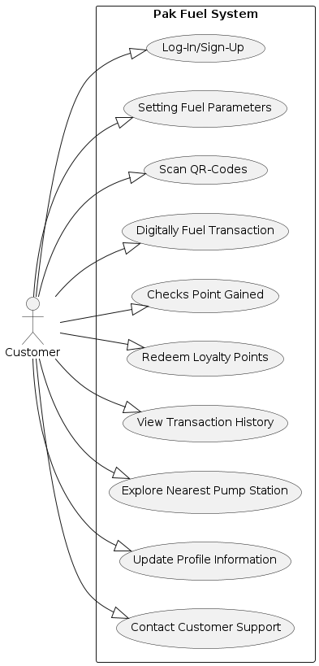

Figure 2 Use Case - General User

### Use Case Diagram –Pump Station Owner.

This diagram represents the interactions between the Pump Station Owner and the system. Key use cases involve managing transactions and administering the loyalty program.

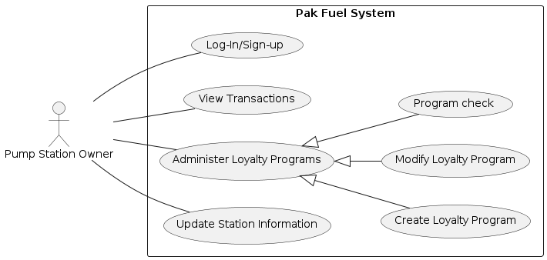

Figure 3 Use case -Pump Station owner

### Use Case Diagram – Service Personnel

The use case diagram for Service Personnel showcases their involvement in scanning QR codes and assisting users with transactions.

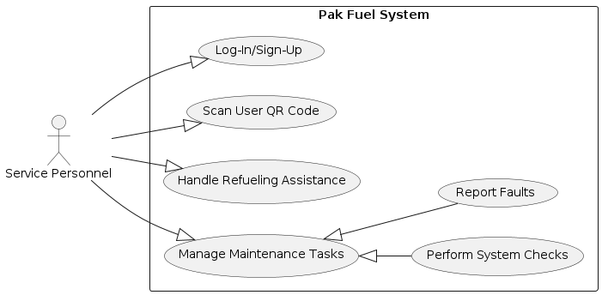

Figure 4 Use Case - Service Personnel

### Use Case Diagram – Admin.

This diagram outlines the interactions between the Admin and the system, including managing Pump Stations and ensuring system integrity.

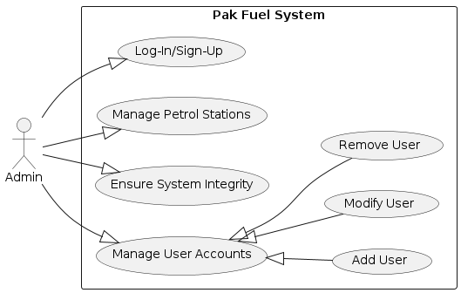

Figure 5 Use Case - Admin

## Descriptive Use Cases

Users access the application through log-in or sign-up processes, ensuring a personalized experience. This use case is fundamental for user engagement and interaction.

|  |  |
| --- | --- |
| **ID:** | **Use Case 1** |
| **Title:** | Authentication |
| **Description:** | User logs in or signs up to access the application. |
| **Primary Actor:** | General Users |
| **Preconditions:** | None |
| **Post conditions:** | User Is logged in or signed up successfully |
| **Main Success Scenario:** | 1. User Opens the app 2. User enters credential 3. User logs in |
| **Alternative Scenario:** | * None |
| **Frequency of Use:** | Daily |

Table 1 –Descriptive Use Case Table

Users customize fuel parameters to tailor transactions according to their preferences. This feature adds flexibility and convenience to the fuel purchasing process.

|  |  |
| --- | --- |
| **ID:** | **Use Case 2** |
| **Title:** | Setting Fuel Parameters |
| **Description:** | User adjust or sets fuel parameters for transaction |
| **Primary Actor:** | General user |
| **Preconditions:** | User is logged in |
| **Post conditions:** | Fuel parameters are updated |
| **Main Success Scenario:** | 1. User Navigates to setting 2. User adjust fuel parameters |
| **Alternative Scenario:** | None |
| **Frequency of Use:** | Regularly |

Table 2 - Descriptive Use Case Table

Users utilize QR code scanning to verify and authenticate transactions, enhancing security and reducing manual input errors.

|  |  |
| --- | --- |
| **ID:** | **Use Case 3** |
| **Title:** | Scan QR Code |
| **Description:** | User Scan QR codes for transaction verification |
| **Primary Actor:** | General User |
| **Preconditions:** | User is Logged in |
| **Post conditions:** | Transaction is verified |
| **Main Success Scenario:** | 1. User selects the scan option 2. User scans the QR code. |
| **Alternative Scenario:** | None |
| **Frequency of Use:** | Regularly |

Table 3 - Descriptive Use Case Table

Users make digital transactions for fuel purchases, providing a seamless and efficient alternative to traditional payment methods.

|  |  |
| --- | --- |
| **ID:** | **Use Case 4** |
| **Title:** | Digitally Purchase Fuel |
| **Description:** | User making a digital transaction to purchase fuel |
| **Primary Actor:** | General User |
| **Preconditions:** | User is logged in |
| **Post conditions:** | Fuel is purchase, transaction completed |
| **Main Success Scenario:** | 1. User selects the purchase option 2. User selects the fuel type and amount 3. User confirm transaction |
| **Alternative Scenario:** | * Transaction fails due to connectivity issues. |
| **Frequency of Use:** | Regularly |

Table 4 - Descriptive Use Case Table

Users check their accumulated loyalty points, offering insight into their engagement and potential benefits.

|  |  |
| --- | --- |
| **ID:** | **Use Case 5** |
| **Title:** | Check Loyalty Points |
| **Description:** | User checks accumulated loyalty points |
| **Primary Actor:** | General User |
| **Preconditions:** | User is logged in. |
| **Post conditions:** | Loyalty points displayed |
| **Main Success Scenario:** | 1. User navigates to loyalty section. 2. User views loyalty points. |
| **Alternative Scenario:** | None |
| **Frequency of Use:** | Occasionally |

Table 5 - Descriptive Use Case Table

Users redeem loyalty points for rewards or discounts, encouraging user retention and loyalty.

|  |  |
| --- | --- |
| **ID:** | **Use Case 6** |
| **Title:** | Redeem Loyalty Points |
| **Description:** | User uses loyalty points for benefits or discounts |
| **Primary Actor:** | General User |
| **Preconditions:** | User is logged in. |
| **Post conditions:** | Loyalty points redeemed. |
| **Main Success Scenario:** | 1. User selects redeem option. 2. User chooses the item or benefit to redeem |
| **Alternative Scenario:** | None |
| **Frequency of Use:** | Occasionally |

Table 6 - Descriptive Use Case Table

Users review their digital transaction history, promoting transparency and record-keeping for personal and financial tracking.

|  |  |
| --- | --- |
| **ID:** | **Use Case 7** |
| **Title:** | View transaction history |
| **Description:** | User check the transaction history |
| **Primary Actor:** | General use |
| **Preconditions:** | User is logged in. |
| **Post conditions:** | Transaction history displayed. |
| **Main Success Scenario:** | 1. User navigates to transaction history. 2. User views the past made transactions |
| **Alternative Scenario:** | None |
| **Frequency of Use:** | Occasionally |

Table 7 - Descriptive Use Case Table

Users search for nearby pump stations, facilitating location-based decision-making and enhancing user convenience.

|  |  |
| --- | --- |
| **ID:** | **Use Case 8** |
| **Title:** | Nearest pump stations |
| **Description:** | User Searches for nearest pump stations. |
| **Primary Actor:** | General User |
| **Preconditions:** | User is logged in. |
| **Post conditions:** | List of the nearest pump stations |
| **Main Success Scenario:** | 1. User select the explore option. 2. User views the list of nearby pump stations. |
| **Alternative Scenario:** | None |
| **Frequency of Use:** | Occasionally |

Table 8 - Descriptive Use Case Table

Users modify their profile information, allowing them to keep their details up-to-date and relevant.

|  |  |
| --- | --- |
| **ID:** | **Use Case 9** |
| **Title:** | Update profile |
| **Description:** | User modifies personal information |
| **Primary Actor:** | User |
| **Preconditions:** | User is logged in. |
| **Post conditions:** | Profile information updated |
| **Main Success Scenario:** | 1. User go to the profile settings. 2. User updates the information. |
| **Alternative Scenario:** | None |
| **Frequency of Use:** | Occasionally |

Table 9 - Descriptive Use Case Table

Users access customer support for assistance, ensuring a reliable channel for issue resolution and support.

|  |  |
| --- | --- |
| **ID:** | **Use Case 10** |
| **Title:** | Contact Customer Support |
| **Description:** | User reaches out to customer support for assistance. |
| **Primary Actor:** | User |
| **Preconditions:** | User is logged in. |
| **Post conditions:** | Customer support Contacted |
| **Main Success Scenario:** | 1. User goes to support section. 2. User send a query or contacts support. |
| **Alternative Scenario:** | None |
| **Frequency of Use:** | Occasionally |

Table 10 - Descriptive Use Case Table

Pump Station Owners log in or sign up to access the application's owner-specific functionalities, facilitating station management.

|  |  |
| --- | --- |
| **ID:** | **Use Case 11** |
| **Title:** | Log-In/Sign-Up (For Pump Owner Profile) |
| **Description:** | Use Pump Station Owner logs in or signs up to access the owner's functionalities. |
| **Primary Actor:** | Pump Station Owner |
| **Preconditions:** | Owner account exists. |
| **Post conditions:** | Owner is logged in or signed up successfully. |
| **Main Success Scenario:** | 1. Owner opens the app. 2. Owner enters credentials. 3. Owner logs in or signs up. |
| **Alternative Scenario:** | None |
| **Frequency of Use:** | Daily |

Table 11 - Descriptive Use Case Table

Pump Station Owners manage and oversee loyalty programs for customers, promoting customer engagement and retention.

|  |  |
| --- | --- |
| **ID:** | **Use Case 12** |
| **Title:** | Administer Loyalty Program |
| **Description:** | Pump Station Owner manages and oversees loyalty programs for customers. |
| **Primary Actor:** | Pump Station Owner |
| **Preconditions:** | Owner is logged in. |
| **Post conditions:** | Loyalty program completed. |
| **Main Success Scenario:** | 1. Owner accesses loyalty program interface. 2. Owner views and manages loyalty programs. |
| **Alternative Scenario:** | None |
| **Frequency of Use:** | Occasionally |

Table 12 - Descriptive Use Case Table

Pump Station Owners make adjustments or modifications to existing loyalty programs, ensuring adaptability to changing circumstances.

|  |  |
| --- | --- |
| **ID:** | **Use Case 13** |
| **Title:** | Modify Loyalty Program |
| **Description:** | Pump Station Owner makes adjustment or modifications to existing loyalty programs. |
| **Primary Actor:** | Pump Station Owner |
| **Preconditions:** | Owner is logged in. |
| **Post conditions:** | Loyalty Program Modified |
| **Main Success Scenario:** | 1. Owner selects modify option. 2. Owner adjusts program parameters. |
| **Alternative Scenario:** | None |
| **Frequency of Use:** | Occasionally |

Table 13 - Descriptive Use Case Table

Pump Station Owners create new loyalty programs to attract and retain customers, fostering customer loyalty and satisfaction.

|  |  |
| --- | --- |
| **ID:** | **Use Case 14** |
| **Title:** | Create Loyalty Programs |
| **Description:** | Pump Station Owner creates new loyalty programs for customers. |
| **Primary Actor:** | Pump Station Owner |
| **Preconditions:** | Owner is logged in. |
| **Post conditions:** | New loyalty program created |
| **Main Success Scenario:** | 1. Owner selects create option. 2. Owner defines new loyalty program. |
| **Alternative Scenario:** | None |
| **Frequency of Use:** | Occasionally |

Table 14 - Descriptive Use Case Table

Pump Station Owners update information related to their stations, keeping details accurate and up-to-date.

|  |  |
| --- | --- |
| **ID:** | **Use Case 15** |
| **Title:** | Update Station Information |
| **Description:** | Pump Station Owner updates information related to the station. |
| **Primary Actor:** | Pump Station Owner |
| **Preconditions:** | Owner is logged in. |
| **Post conditions:** | Station Information updated |
| **Main Success Scenario:** | 1. Owner accesses station information. 2. Owner updates relevant details. |
| **Alternative Scenario:** | None |
| **Frequency of Use:** | Occasionally |

Table 15 - Descriptive Use Case Table

DAGHA COPY USE CASE DI New jorha wang dapara ma ishti di(was mazi confirm c, si har usecase gha table jorh km kana )

|  |  |
| --- | --- |
| **ID:** | **Use Case 8** |
| **Title:** | Nearest pump stations |
| **Description:** | User Searches for nearest pump stations. |
| **Primary Actor:** | General User |
| **Preconditions:** | User is logged in. |
| **Post conditions:** | List of the nearest pump stations |
| **Main Success Scenario:** | 1. User select the explore option. 2. User views the list of nearby pump stations. |
| **Alternative Scenario:** | None |
| **Frequency of Use:** | Occasionally |

|  |  |
| --- | --- |
| **ID:** | **Use Case 8** |
| **Title:** | Nearest pump stations |
| **Description:** | User Searches for nearest pump stations. |
| **Primary Actor:** | General User |
| **Preconditions:** | User is logged in. |
| **Post conditions:** | List of the nearest pump stations |
| **Main Success Scenario:** | 1. User select the explore option. 2. User views the list of nearby pump stations. |
| **Alternative Scenario:** | None |
| **Frequency of Use:** | Occasionally |

|  |  |
| --- | --- |
| **ID:** | **Use Case 8** |
| **Title:** | Nearest pump stations |
| **Description:** | User Searches for nearest pump stations. |
| **Primary Actor:** | General User |
| **Preconditions:** | User is logged in. |
| **Post conditions:** | List of the nearest pump stations |
| **Main Success Scenario:** | 1. User select the explore option. 2. User views the list of nearby pump stations. |
| **Alternative Scenario:** | None |
| **Frequency of Use:** | Occasionally |

|  |  |
| --- | --- |
| **ID:** | **Use Case 8** |
| **Title:** | Nearest pump stations |
| **Description:** | User Searches for nearest pump stations. |
| **Primary Actor:** | General User |
| **Preconditions:** | User is logged in. |
| **Post conditions:** | List of the nearest pump stations |
| **Main Success Scenario:** | 1. User select the explore option. 2. User views the list of nearby pump stations. |
| **Alternative Scenario:** | None |
| **Frequency of Use:** | Occasionally |

Table 16 – Sample Descriptive Use Case Table

|  |  |
| --- | --- |
| **ID:** | **Use Case 8** |
| **Title:** | Nearest pump stations |
| **Description:** | User Searches for nearest pump stations. |
| **Primary Actor:** | General User |
| **Preconditions:** | User is logged in. |
| **Post conditions:** | List of the nearest pump stations |
| **Main Success Scenario:** | 1. User select the explore option. 2. User views the list of nearby pump stations. |
| **Alternative Scenario:** | None |
| **Frequency of Use:** | Occasionally |

## Activity Diagram of System

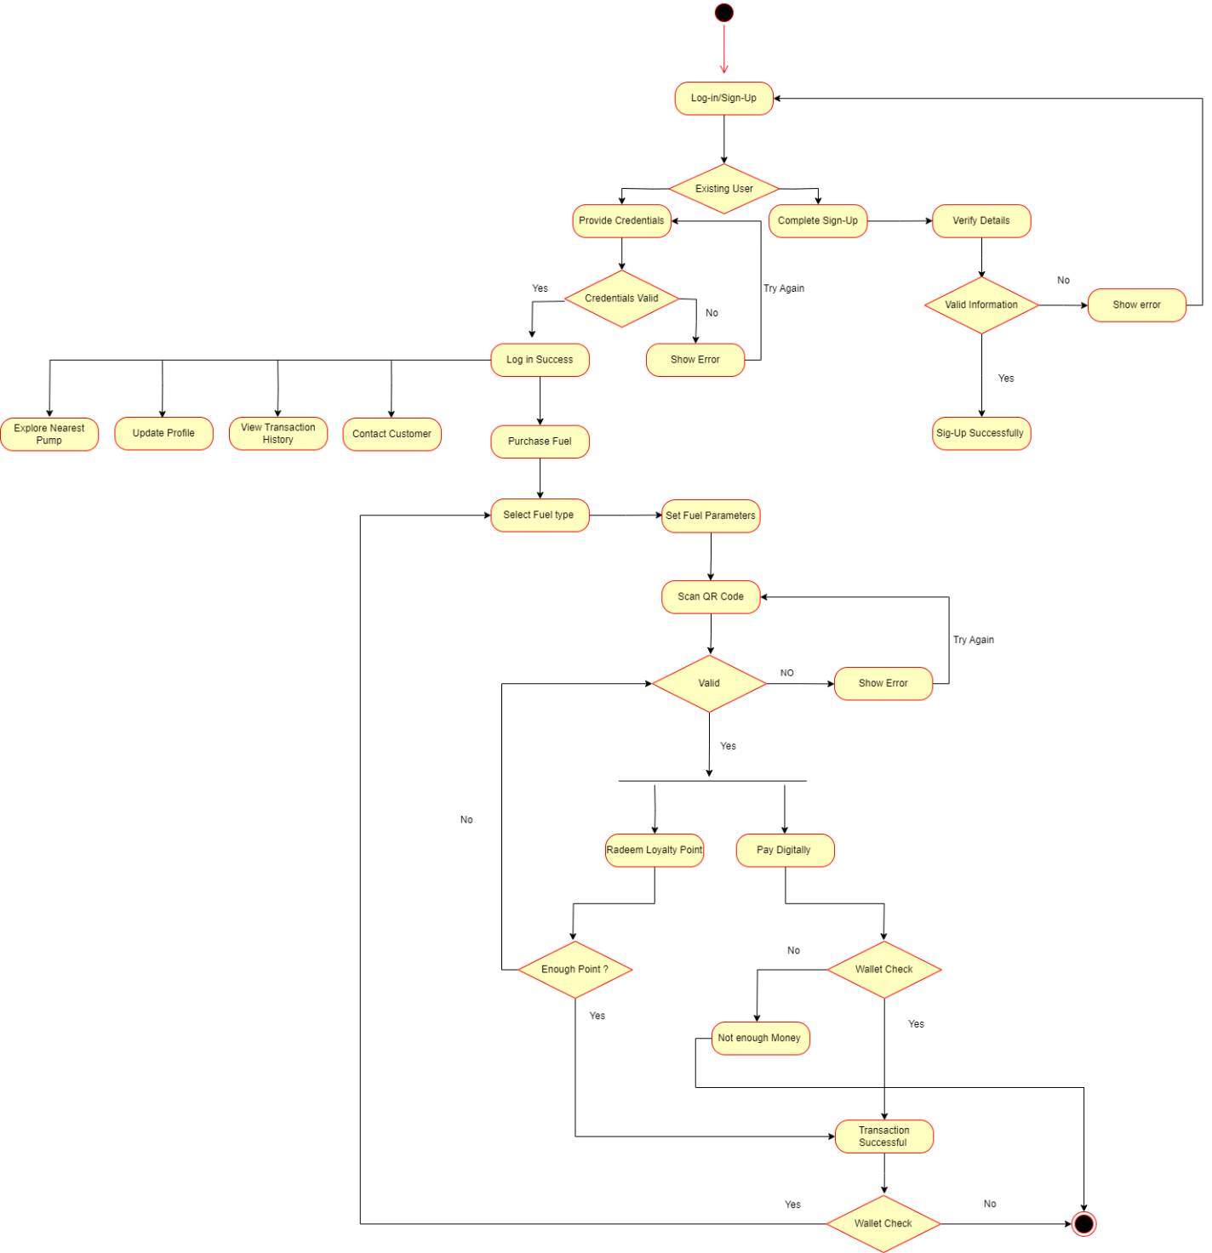

Figure 6 Activity Diagram -1

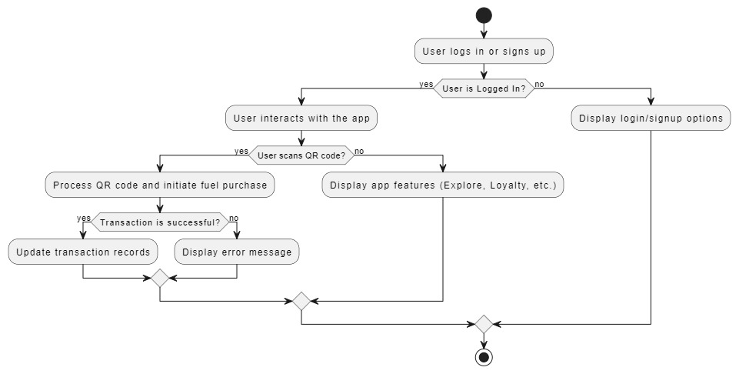

Check Diagram above

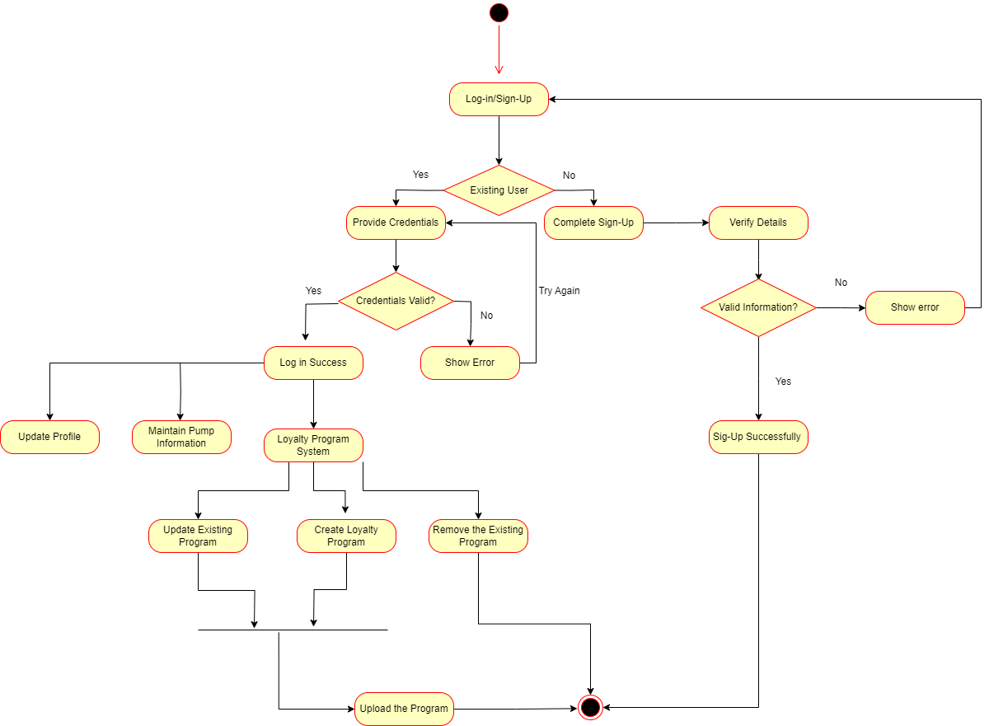

Figure 7 Activity Diagram -2

## Data Flow Diagrams

### Context Level Diagram

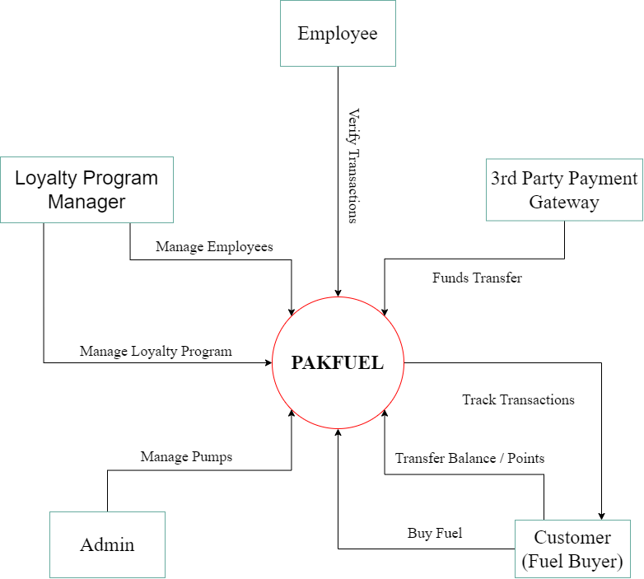

Figure 8 - Level 0 DFD

### Level 1 DFDs

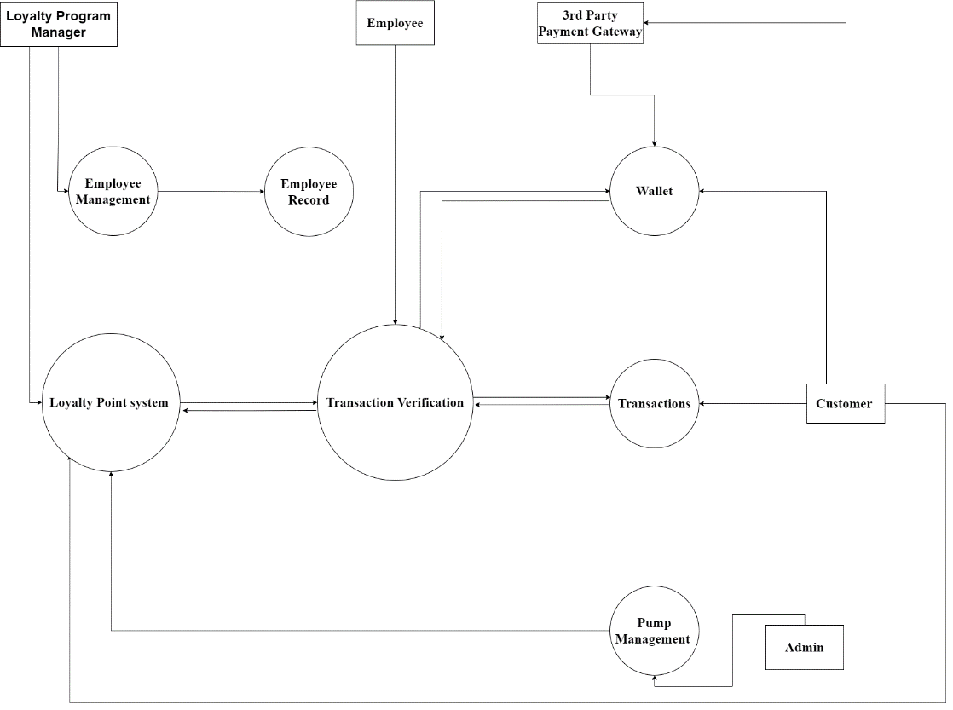

Figure 9 - Level 1 DFD

## Sequence Diagram

### Sequence Diagram – Digitally Fuel Transaction

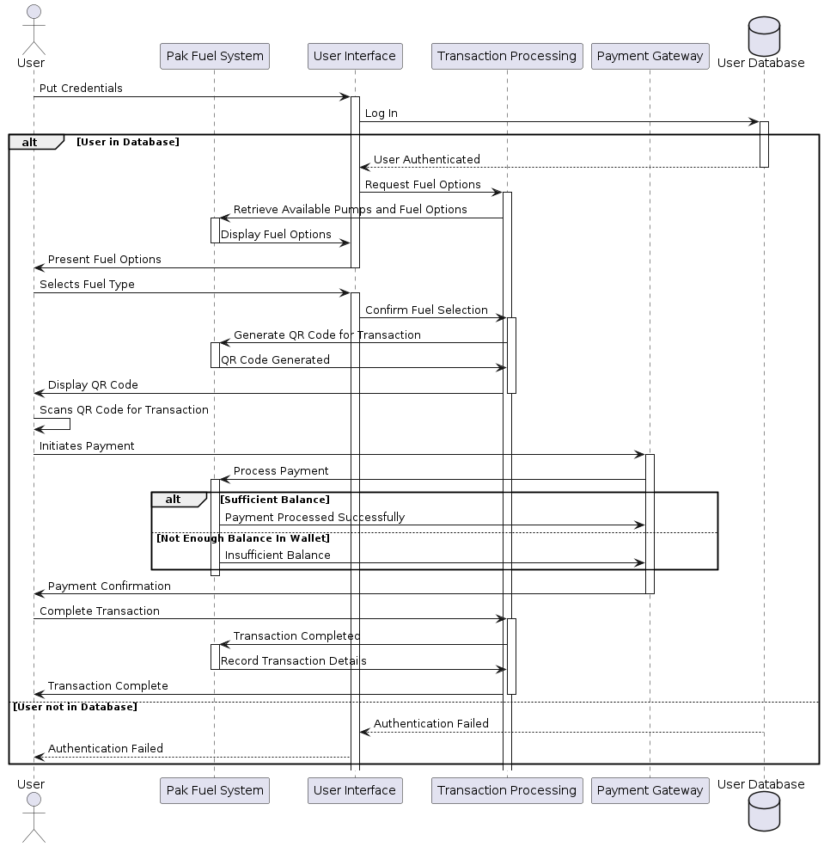

Figure 10- Fuel Transaction - Sequence Diagram

1. **User Authentication**:

* User enters credentials through the UI.
* UI requests authentication from the User Database.
* If the user is authenticated, proceed; otherwise, authentication fails.

1. Fuel Selection:

* User requests available fuel options through the UI.
* Transaction Processing retrieves pump and fuel options from the system.
* The UI displays available fuel options to the user.

1. **Transaction Processing**:

* User selects a fuel type.
* UI confirms fuel selection with Transaction Processing.
* Transaction Processing generates a QR code for the transaction.
* The system verifies the QR code and prompts the user for payment.

1. **Payment Processing**:

* User initiates payment by scanning the QR code.
* Payment Gateway processes the payment.
* If there is a sufficient balance, the payment is successful; otherwise, an insufficient balance message is displayed.

1. **Transaction Completion**:

* The transaction is completed, and details are recorded.
* Confirmation messages are displayed to the user, indicating a successful or failed transaction.

### Sequence Diagram –Loyalty Program System.

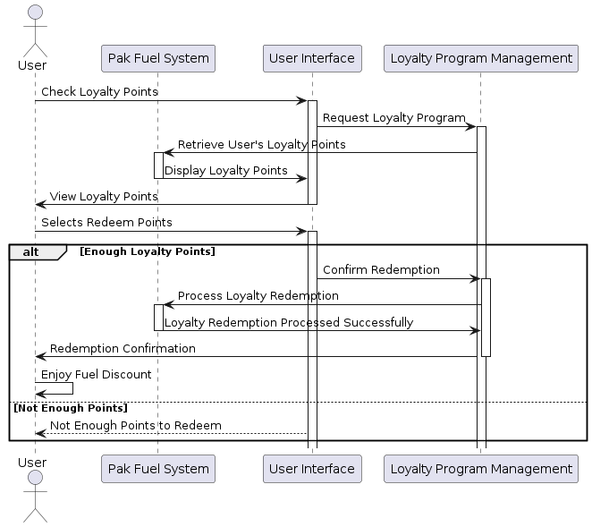

Figure 11- Loyalty Program-Sequence Diagram

1. **Check Loyalty Points**:

* User checks loyalty points through the UI.
* UI requests loyalty points from Loyalty Program Management.

1. **Display Loyalty Points**:

* Loyalty Program Management retrieves user loyalty points from the system.
* UI displays loyalty points to the user.

1. **Redemption Process**:

* User selects to redeem loyalty points through the UI.
* If there are enough points, the redemption process continues; otherwise, a message indicates insufficient points.

1. **Loyalty Redemption**:

* UI confirms redemption with Loyalty Program Management.
* Loyalty Program Management processes loyalty redemption in the system.
* If there are enough points, the redemption is successful; otherwise, a message indicates insufficient points.

1. **Enjoy Fuel Discount**:

* If the redemption is successful, the user enjoys a fuel discount.
* If there are not enough points, a message informs the user of insufficient points to redeem.

## Entity Relationship Diagram

*<An entity–relationship model describes interrelated things of interest in a specific domain of knowledge. A basic ER model is composed of entity types and specifies relationships that can exist between entities. Provide the ER Diagram of the database in your system.>*



Figure 12 – Sample Entity-Relationship Diagram